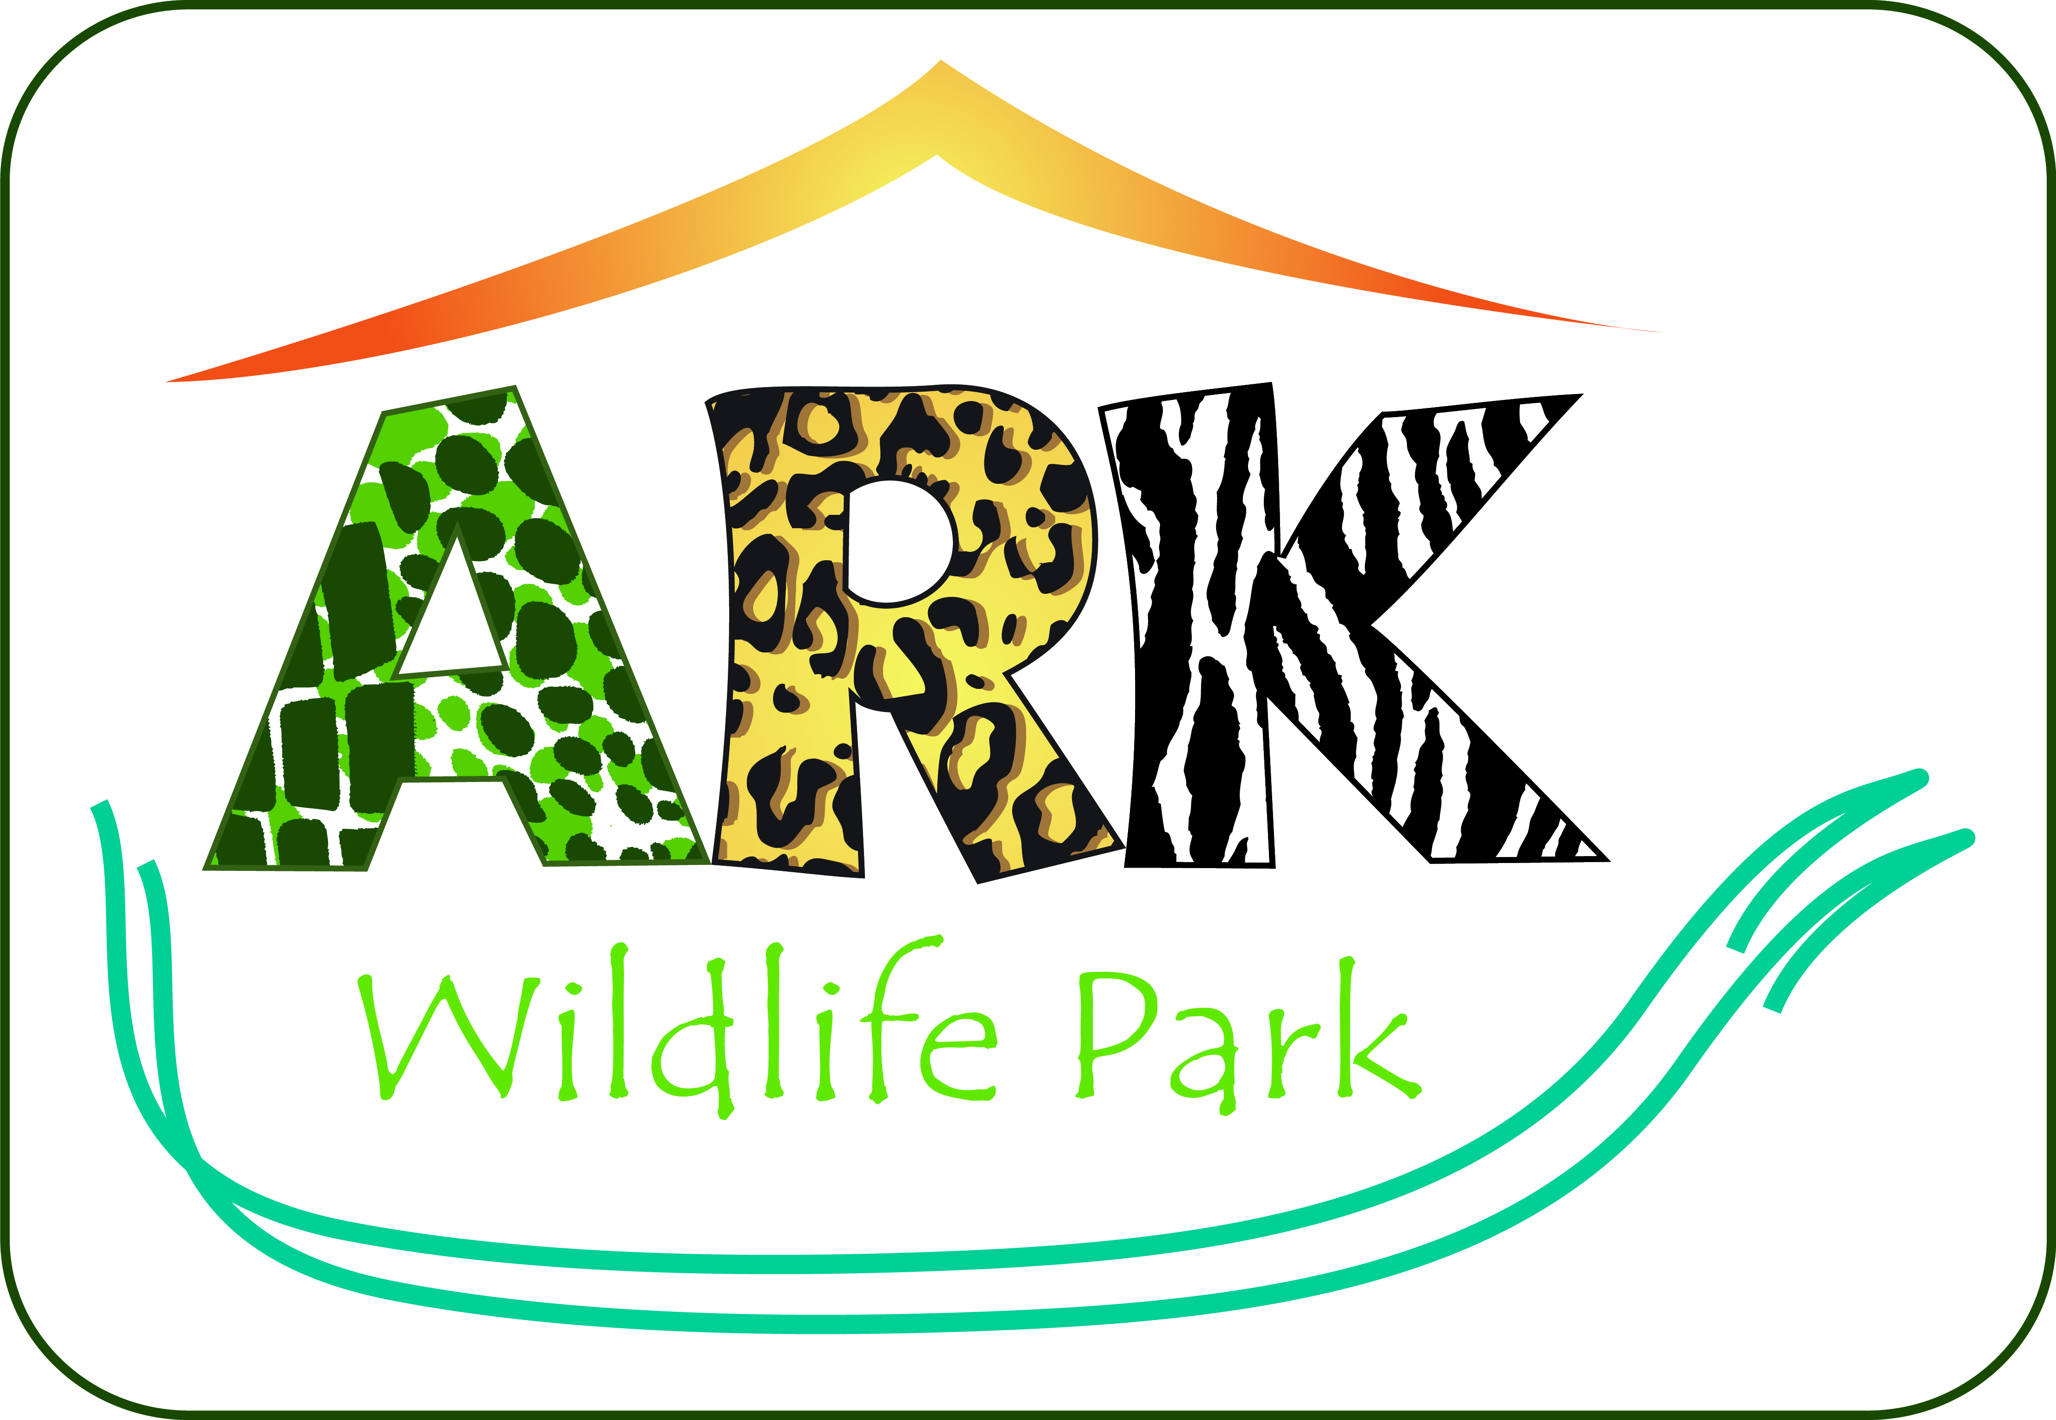
Risk Assessment Guidance – School & Group Visits

The Ark Wildlife Park strives to provide a safe and enjoyable day out for schools and groups. To ensure these groups’ health and safety the Ark Wildlife Park follows a variety of procedures, and has many existing control measures in place.

This risk assessment is for guidance only and gives a general outline of potential risks and controls identified at the Ark Wildlife Park. We are happy for you to use the following information to carry out a risk assessment of our site, but would like to make it clear that these are guidance notes only. Responsibility for carrying out a full risk assessment for your school or group visit to The Ark Wildlife Park remains with the school/group and these notes should not be used in place of that assessment.

Teachers, Group Leaders and any supporting adults are responsible for the behaviour of the students/group members towards the animals, staff, and other visitors.

When in close contact with animals or anything associated with an animal, students/group members should be supervised and teachers must ensure appropriate hygiene afterwards. Teachers/Group Leaders are also responsible to ensure all groups follow posted or verbal instructions and rules.

Play areas are not supervised by Ark Wildlife Park staff and are open to general visitors. Please ensure there is adequate supervision at all times.

Hazard | Associated Risk | Risk Level | Existing Control Measures
Contact with Animals | Animal bites, scratches, pecking, allergic reaction, etc. | Low | - Only suitable animals are chosen for handling.  - Animals have a period of adjustment during which they become used to being handled before being presented to visitors.  - Care is taken to ensure that animals are handled in rotation, to avoid stressing animals by over-handling  - Animal encounter staff will explain the appropriate method of handling animals before proceeding.  - Only visitors who show they are willing and confident (by raising their hands) will be given animals to handle.  - Animal encounter staff will remove animals if they are showing signs of agitation.  - Visitors should refrain from making loud noises and moving around during handling sessions.  - Suitably constructed safety barriers. Warning signs.  - No feeding policy except in designated areas. Please note animals may only be fed the food provided by the Ark Wildlife Park.  - Trained Emergency First Aiders are on site and First Aid equipment is available at the Kalahari Café Reception Desk.  - Staff in radio contact in case of emergencies.  - Signage warning visitors that certain animals may bite.  - Visitors should not enter animal enclosures except for organised handling activities.
Contact with Animals | Disease | Low | - A risk assessment has been carried out in relation to “Public contact with Reptiles”.  - Where animals are used for handling sessions or public feeds hand washing facilities are available.  - All reptiles and animals used for handling are regularly health screened.  - Enclosures are cleaned and inspected daily  - Children under 12 months old should not handle animals.  - Visitors may only feed animals in designated areas and with the food provided by the Ark Wildlife Park.
Contact with Animals | Insect Bites – severe allergic reaction, anaphylactic shock (rare) | Low | - Bee and wasp sting emergency procedure in place.  - Teachers/group leaders are advised that any students that are known to have a severe allergic reaction to stings must have the appropriate medication with them and understand how it should be administered.  - The company has regular inspections to remove any wasp nests; however it is not company policy to destroy bee nests/hives.  - Trained Emergency First Aiders are on site and First Aid equipment is available at the Kalahari Café Reception Desk.
Animal Escape | Risk of injury from animal | Low | - Animal escape procedures in place  - Staff in radio contact in case of emergencies.  - Security of enclosures are strictly controlled  - Visitors will be advised by members of staff regarding any safety controls required  - In the unlikely event that a dangerous animal escapes, the staff are trained to lead their recapture.
Enclosures – Electric Fencing | Risk of Electrocution | Low | - Stand-off barriers to prevent contact.  - Warning signs in place where appropriate  - Low voltage fence.
Nettles/Brambles & Trees | Risk of scratches/stings and falling branches | Low | - Regular cutting back and control measures in place.  - Regular inspection of trees
Slopes, steps, uneven surfaces, wet leaves and mud | Slips, trips, falls, grazes, sprains and other injuries | Low | - Daily inspection of all paths, carpets and stairs undertaken with reporting system in place to deal with defects.  - Any unsafe areas will be closed to the public during adverse weather.
Trees | Risk of injury due to falling trees | Low | - Tree Risk Assessment and Inspection carried out annually.  - Six monthly inspection by qualified forester undertaken
Pond & Lake Area | Risk of accidental drowning | Low | - Fences and barriers in place.  - Warning signs  - Buoyancy aids around lake  - Group organisers to ensure that no climbing takes place on or over these barriers and that children are supervised at all times with particular attention when entering the area around the lake.
Lost Children | Child may enter out of bounds areas, contact with unknown adult | Low | - Staff are visible around the park and can be contacted if a child is lost.  - Park staff are identified by the dark green uniform with the Ark logo  - Staff equipped with radios to alert other staff members to a lost child.  - Collection point for lost children is in the Reception Area in the Kalahari Café.  - Lost Child policy in place.
Disabled Visitors | Risk of injury if accessing unsuitable areas | Low | - Disabled toilets are available in the Kalahari café  - All exhibits are on ground level and easily accessible.  - The Ark Wildlife Park is happy to accommodate the requirements of visitors with special needs whenever they can. Schools and group leaders must ensure that suitable arrangements are in place in order that appropriate supervision and assistance is available.
Fire | Risk of Injury | Low | - Fire Procedures are in place  - Evacuation Procedure for the whole park in place.  - Staff are fully trained in emergency procedures  - Regular risk assessments undertaken.  - Firefighting equipment is available and maintained
Hot Weather | Sunburn/Sunstroke/Dehydration | Low | - Large number of undercover and shaded areas available.  - Small children should wear sun hats  - Drinking water available at the Kalahari Café  - Visitors are advised to wear sun cream or sun block in conditions of strong sunlight.  - Sun cream available in Kalahari Shop
Wet Weather | Adverse reaction to cold or wet conditions | Low | - There is a large amount of undercover areas which include extensive animal houses as well as the Activity Barn and Kalahari café.  - Visitors should bring wet weather clothing if rain is forecast.  - Wet weather gear available in Kalahari Shop
Play Area | Risk of injury from falling off play equipment | Low | - Safety checks are carried out every day and regular maintenance carried out  - Unsafe equipment will be put out of service until repaired/replaced  - Teachers/Group leaders advised to supervise children at all times.  - Play bark has been placed around the base of the play equipment  - Older groups of children are not permitted on play equipment to prevent potential injury to smaller, younger children. The play equipment is suitable for 12 years and under.
Park & Staff Vehicles | Risk of accidental injury | Low | - No keys left in vehicles  - Vehicles will ordinarily be parked in the car park and not within the park grounds  - If there is a requirement for park staff to bring vehicles into the grounds – they will ensure they drive with due care and attention.  - Any other vehicles in the park will be under the supervision of a member staff  - Speed limit on site is 5 miles per hour
Anti-Social Behaviour by visitors climbing on, or jumping over railings, fencing, trees, walls, raised walkways, seating etc. | Risk of injury from falling and injury to others | Low | - Safety notices where relevant  - Park regulations regarding behaviour are displayed at the park entrance.  - Staff monitor and control antisocial behaviour  - Children to be supervised at all times  - Anyone displaying anti-social behaviour will be evicted from the park premises
Kalahari Café & Shop |  |  | - Hygiene regulations are adhered to  - Staff are trained to prepare and serve food and drinks

